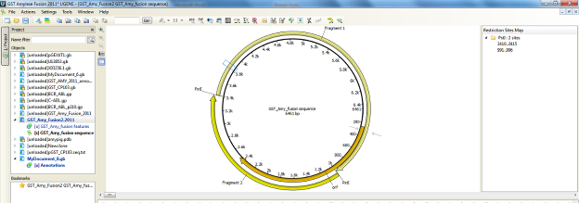

Task report [DigestSequenceTask]

status | Finished
time | 0.00.00.010

Digest into fragments GST_Amy_Fusion2.2011 (circular)
Generated 2 fragments.
1: From PstI (995) To PstI (3410) - 2416 bp
2: From PstI (3414) To PstI (6461) - 3048 bp

