1. I would like to install the NGS package of Ugene 1.32. latest version using the default installer
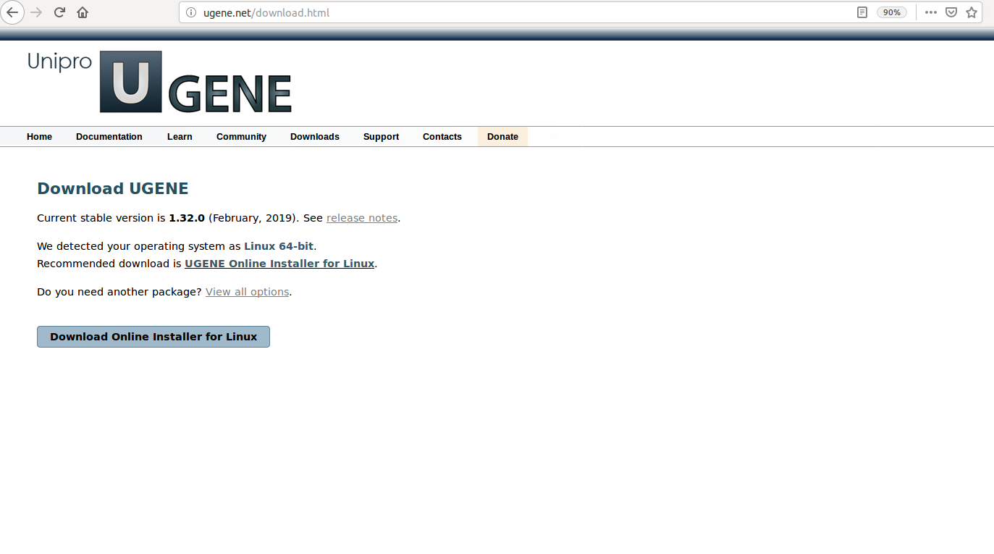
2. I downloaded the Online installer for Linux
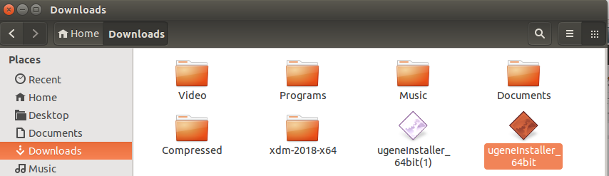

3. I allowed executing the file it as program

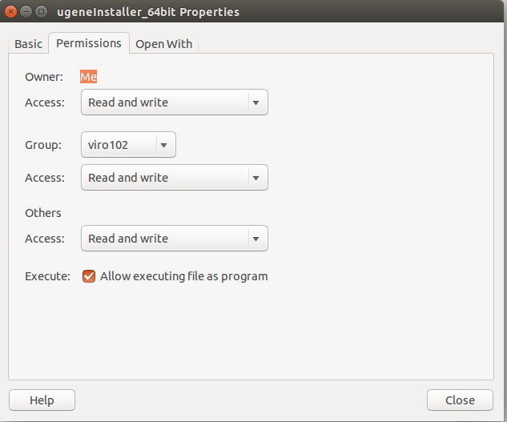
4. but, when I double click on the executable file, it won't launch the online installation. I don't know why ?

